Acme Bank Customers can each have multiple Accounts. Acme bank has 1Million+ customers. Each customer can have any number of
accounts.

Write an SQL query to find out the top 3 High Net worth Customers of Acme bank.
Suggest options/techniques to improve model and query performance
Data is Organized as below

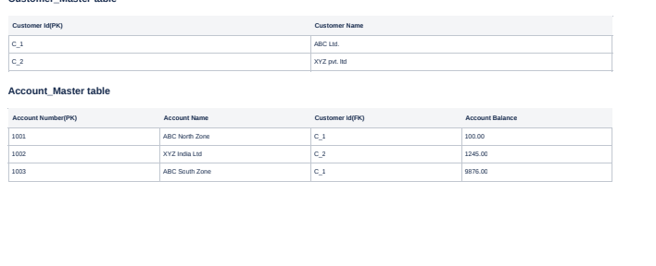
Query :

select am.customer_id,am.account_name,sum(account_balance) from account_master am group by am.customer_id order by sum(account_balance) desc limit 3;

We can create index on column amount_balance fir a faster fecthing.

